Design Portfolio

**PhotoSpace**

**Problem Finding**

User Problem: Client lacks exposure of their business and photography skills

* Requires a website to showcase photograph portfolio and relevant work
* Portfolio website should promote the photographer’s brand by assigning collection of work to their respective webpage.
* What is required: photo collection, blog entries, testimonials, contact information

**User Persona**

Meet Greg. Greg is a professional photographer with a small business located in his hometown. He is interested in growing his small business through the exposure of his works on PhotoSpace. The photographer wants a simple set of web pages to showcase his photography skills and his passion for this field through the blog articles he writes. Greg emphasizes that internet users see his established reputation in town. The entrepreneur photographer also wants users to stay on the portfolio website for as long as possible. The goal throughout this initiative is to increase client conversions and traffic to the business all while delivering a platform to host Greg’s photography portfolio.

**User Story**

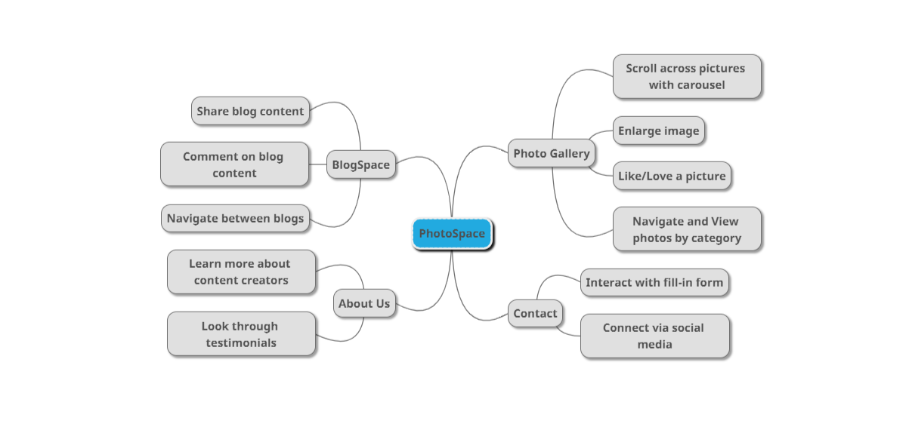

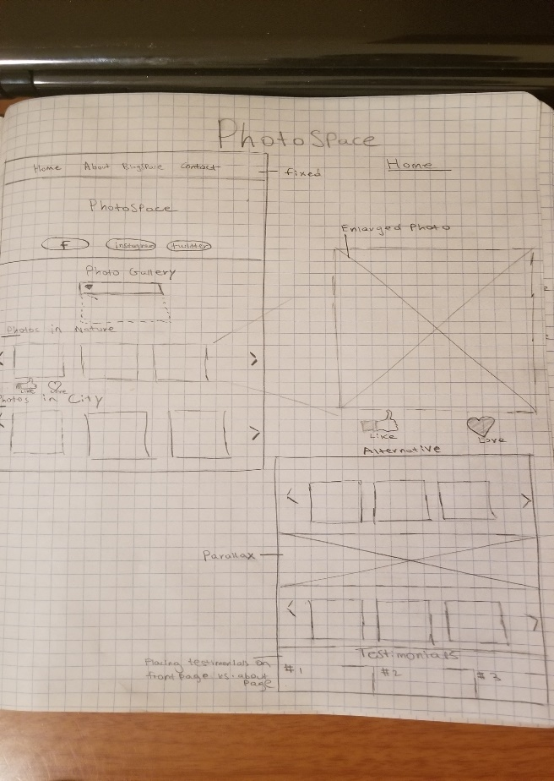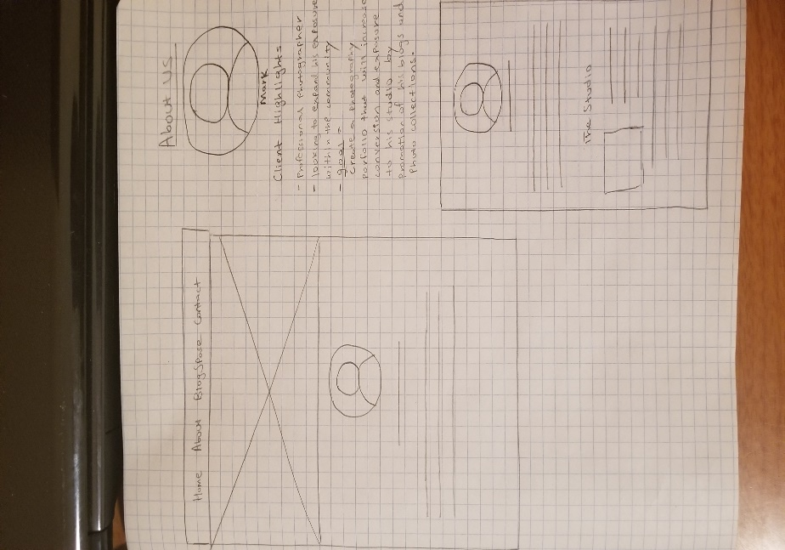

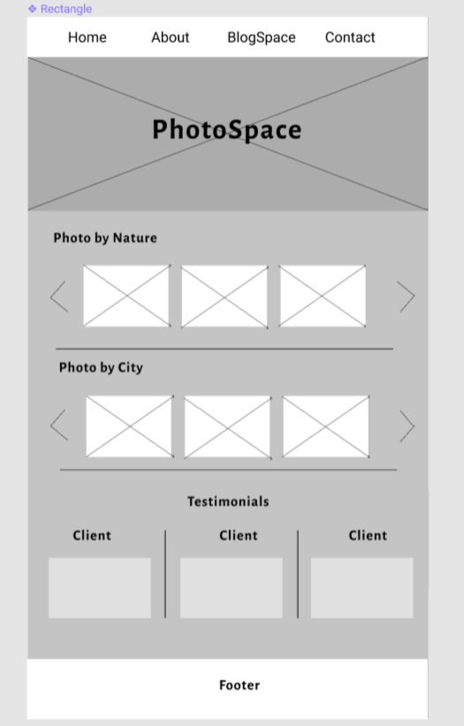





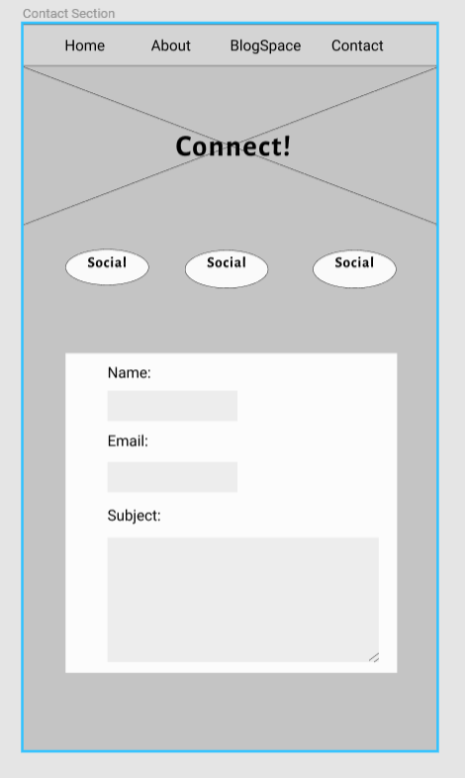

Color Palette:

• #fcfaf7

• #B7A289